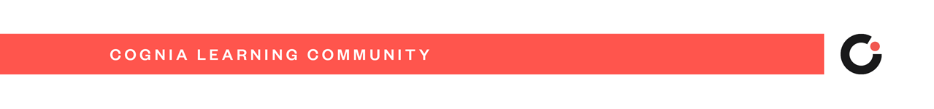
Cognia Learning Community

Dear Teachers,

This email will provide you the information about your access to the Cognia Learning Community account and the professional learning content. We’ve selected this platform and content because it is designed to personalize your professional development experience, much like we personalize our students’ learning experience. You will have access to Learning Labs (modules) to meet your individual professional learning needs and interests.

Here are the steps to access your account:
- You will receive an account confirmation email from “Cognia Home”. Check your spam folder if you do not see it.
- Click the link and complete the fields to create your account.
- From the left navigation bar, click on “Learning Community”.
- Explore!

You will be onboarded and introduced to this professional learning platform through the Asynchronous Teacher Onboarding Learning Lab. Feel free to jump right in or wait until [Leader - Insert explanation for how you will onboard your teachers and the expectations for engagement]

Enjoy “tinkering” and exploring the wide range of topics that will help you create dynamic, innovative learning environments. We’ll learn together and maximize this robust and differentiated content to meet your professional learning needs.

Sincerely,

Need help? Contact Cognia
clientcare@cognia.org

